Telecom Churn Analysis Project
Customer churn is a critical metric for telecom companies, reflecting the percentage of customers who discontinue their services over a period. High churn rates lead to revenue loss and higher customer acquisition costs. Understanding the factors influencing churn can help in designing targeted retention strategies and improving customer satisfaction. The goal of this project is to analyze customer churn using a real-world telecom dataset, identify patterns, and uncover factors that contribute to churn. This analysis includes demographic factors, service plans, contract types, payment methods, and additional features such as unlimited data and device protection plans.
Data Source
The dataset used in this project is publicly available on Hugging Face and contains information on telecom customers, including demographics, services, billing, and churn status.
Dataset Link: Telco Customer Churn Dataset on Hugging Face Dataset Type: Structured CSV data suitable for analysis Sample Features: Customer Details: Customer ID, Gender, Age, City Service Information: Contract Type, Internet Service, Device Protection Plan, Streaming Services Billing Information: Monthly Charges, Payment Method, Paperless Billing Target Variable: Churn (Yes/No) This dataset provides a comprehensive view of customer behavior in the telecom domain and allows detailed analysis of factors influencing churn.

Data Ingestion
The first step in the analytics pipeline is data ingestion, which involves importing raw data into the working environment. The CSV dataset was loaded into a Pandas DataFrame, providing a structured format suitable for data analysis. The first few rows were inspected to confirm that data is loaded correctly, and column names and values are as expected. Purpose of this stage: Bring raw data into a structured format for cleaning and analysis Ensure that the dataset is ready for preprocessing and exploration
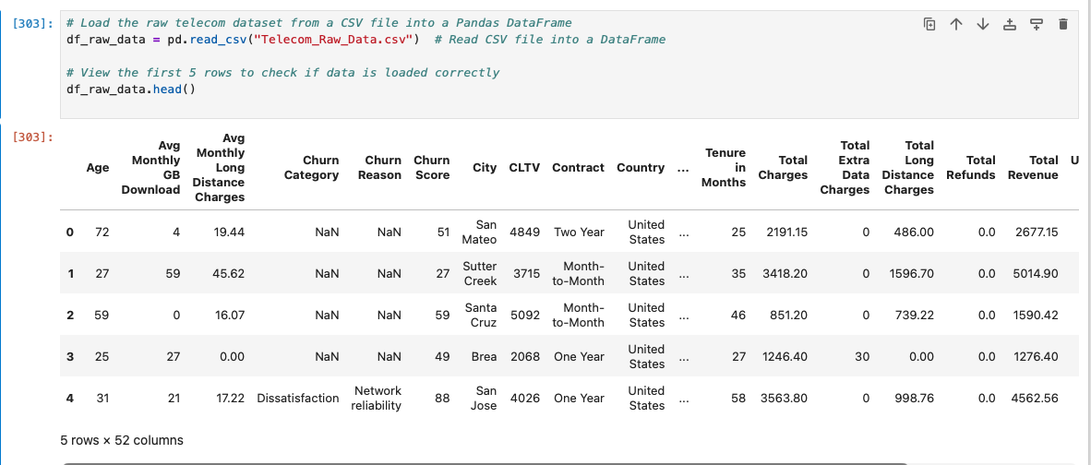

Data Understanding
After ingestion, the data understanding stage helps explore the dataset to identify its structure, quality, and characteristics. Key checks include: Shape of the dataset Dataset contains 7032 rows and 52 columns, indicating a moderately sized dataset with multiple features relevant to churn analysis. DataFrame Info Data types and non-null counts were examined. Most columns have complete data; some columns such as Internet Type, Offer, Churn Category, and Churn Reason contain missing values. This helps in planning data cleaning steps. Summary Statistics Numeric columns like Age, Avg Monthly GB Download, Monthly Charges, and CLTV were summarized. This provides an overview of central tendencies, spread, and potential outliers. Null Values Columns with missing values were identified: Internet Type: 886 missing Offer: 2324 missing Churn Category and Churn Reason: 3104 missing Missing values indicate areas requiring imputation or replacement in data cleaning. Duplicated Rows No duplicated rows were found, confirming the dataset contains unique customer records.
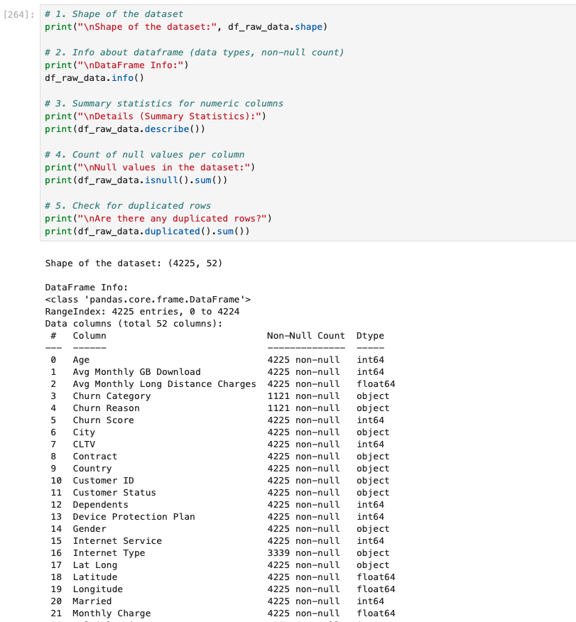

Data Engineering
It is a critical step in the data analytics pipeline that involves preparing raw data for analysis. This stage focuses on cleaning, transforming, and structuring the dataset so that it can be effectively used for modeling and visualization. Proper data engineering ensures accuracy, consistency, and reliability of the insights generated. In this project, the following data engineering tasks were performed:
Removing Redundant Columns: Checked location-related columns (State, Country, Zip Code, City) and found that all customers are from the US, California, making State and Country redundant. Columns such as Latitude, Longitude, and Lat Long were unnecessary for churn analysis. Under 30 and Senior Citizen were removed because the Age column already provides the necessary demographic information. Columns like Quarter and Married were also dropped as they are not relevant to churn analysis. Result: A cleaner dataset with only relevant features for churn prediction.
Ensuring Unique Identifiers: Verified that Customer ID is unique for all records. This step confirms that each row represents a distinct customer, preventing duplication issues in analysis.
Updating Churn-Related Columns: Churn Category and Churn Reason are meaningful only for customers who churned. For non-churned customers, these columns were updated to "Not Available" to indicate the absence of churn reasons.
Handling Missing Values Offer column: Missing values were replaced with "No Offer". Internet Type column: Missing values were replaced with "Unknown". This ensures completeness of categorical data and prevents errors in analysis.
Converting Boolean/Binary Columns: Columns representing Yes/No or 0/1 features (e.g., Device Protection Plan, Internet Service, Multiple Lines, Churn) were converted to "Yes" and "No" for readability. This transformation makes the data easier to interpret during analysis and visualization.
Saving the Cleaned Data: The cleaned dataset was exported to a CSV file for future analysis. This step ensures that the preprocessed data can be reused without repeating the cleaning steps.
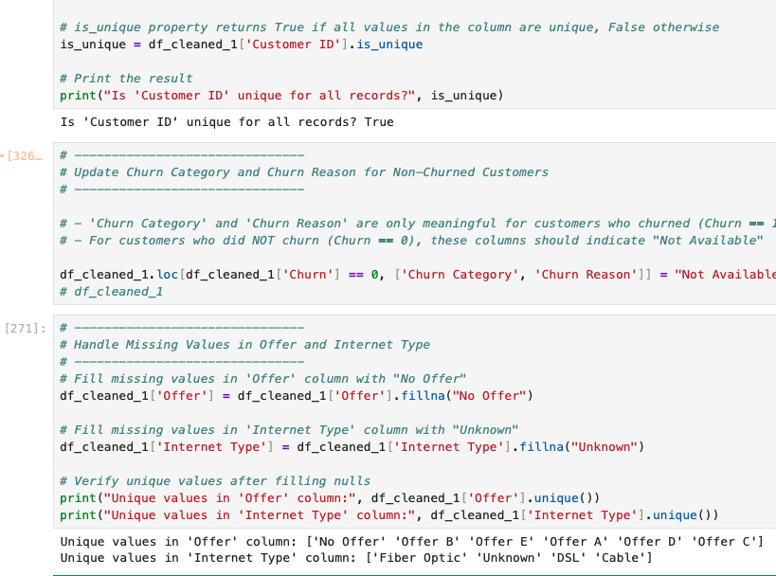

Analytics Computation
In this phase, the cleaned dataset is analyzed to uncover patterns, trends, and relationships between features and customer churn. Key metrics such as churn rates, customer status distribution, and service usage are computed to quantify customer behavior. Visualizations like pie charts, bar charts, and heatmaps are used to make these insights clear and actionable. This step forms the foundation for identifying factors that influence churn and guiding business decisions.
Customer Status Analysis: The dataset shows that 67% of customers have stayed, 27% have churned, and 6% are newly joined. This indicates a substantial churn segment that requires attention. Visualizing this distribution with a pie chart helps quickly understand the balance between retained, churned, and new customers, providing a clear overview of customer retention trends.
Churn Analysis by Contract Type: Month-to-Month customers have the highest churn, showing they are the most unstable. One-Year contracts show moderate churn, indicating slightly better loyalty. Two-Year contracts have the lowest churn, reflecting strong retention among long-term customers. Overall, retention improves as contract length increases due to discounts, perceived switching costs, and better service satisfaction. This highlights that contract type is an important factor influencing churn. A stacked bar chart was used to visualize the churn distribution across different contract types.
Insights Based on Customer Demographics: Gender-wise Churn Analysis Female customers have a slightly higher churn rate (27.27%) compared to male customers (25.80%), a difference of only 1.47 percentage points. Overall, churn levels are fairly similar across genders, indicating that gender alone is not a strong driver of churn. A simple bar chart was used to visualize the gender-wise churn distribution.
Churn Rate Analysis by Number of Dependents: Churn is highest for customers with no dependents, followed by those with five dependents. Customers with 1–3 dependents show the lowest churn, indicating greater stability and loyalty. Overall, the relationship appears U-shaped: high churn at 0 dependents, low churn at 1–3, and rising churn again at 4–5 dependents. A bar chart was used to visualize churn rates across different numbers of dependents.
Churn Rate Analysis Based on Cities: San Diego has the highest churn rate at 67.86%, meaning more than two-thirds of customers in this city have churned, indicating an urgent need for retention strategies. Other major cities like Escondido, San Jose, Sacramento, and San Francisco show significant churn rates around 28–30%, requiring targeted campaigns or service improvements. Los Angeles, Glendale, and Oakland have moderate churn rates (22–27%) and should be monitored proactively. Fresno and Long Beach show relatively low churn rates (17–21%), suggesting better customer retention and satisfaction. A horizontal bar chart was used to visualize the top 10 cities with the highest churn rates for cities with at least 30 customers.
Insights Based on Offer Type: Churn Analysis Offer E has the highest churn rate at 54.53%, indicating that more than half of the customers subscribing to this offer are leaving, possibly due to dissatisfaction or unmet expectations. Offers A and B exhibit very low churn (5.96% and 12.43%), suggesting high customer satisfaction and loyalty; these can serve as benchmarks for retention strategies. Customers with No Offer show moderate churn (26.89%), highlighting an opportunity to engage them with incentives. Offers C and D have churn rates slightly above 24–27%, indicating a need for better engagement or added benefits. A stacked bar chart was used to visualize the churn distribution across different offer types.
Churn Rate Analysis Based on Phone Service and Internet Type: Fiber Optic users with Phone Service show the highest churn at 40.07%, indicating potential dissatisfaction with pricing, service quality, or competition. Customers without Phone Service churn more for DSL (27.33%) and Cable (19.85%), suggesting that bundled services help reduce churn. DSL customers with Phone Service have the lowest churn (16.82%), reflecting better retention through bundled packages. Cable Internet customers are moderately stable, while the “Unknown” Internet Type shows very low churn (7.22%), highlighting potential data quality issues. A heatmap visualization was used to represent churn percentages across combinations of phone service and internet type.
Churn Analysis Based on Reasons for Leaving:The highest churn among customers is driven by competitor-related factors, including better devices, offers, higher data, and faster speeds. Support-related issues are also significant, with attitude and technical expertise of support staff contributing to churn. Service quality and reliability issues, such as network problems, product dissatisfaction, and limited service range, also play a role. Pricing concerns, including high charges and extra fees, contribute to churn but are not the dominant factors. A horizontal bar chart was used to visualize the frequency of each churn reason, highlighting key areas for improvement.
Churn Analysis by Payment Method and Paperless Billing: Churn rates vary significantly depending on both the payment method and whether the customer opts for paperless billing. Across all payment methods, paperless billing is associated with higher churn compared to customers who receive traditional statements. The highest-risk group is customers paying via Mailed Check with Paperless Billing, showing a churn rate of 42.7%. Bank Withdrawal with Paperless Billing also shows elevated churn, increasing from 20.6% to 39.9%. Customers paying via Credit Card remain the most stable, even with paperless billing, with churn around 21%. A heatmap was used to visualize churn rates for “Yes” only, highlighting the highest-risk segments and making it easier to identify target groups for retention strategies such as billing reminders, educational outreach, or optional paper statements.
Churn Comparison Across Data and Device Protection Plans: Churn varies significantly based on whether customers have Unlimited Data and/or a Device Protection Plan. The lowest churn is observed for customers with both unlimited data and a device protection plan (278 churned out of 1271), indicating higher satisfaction and loyalty. Customers with unlimited data but no protection plan show increased churn (624 customers), highlighting the perceived value of device protection. For customers without unlimited data, churn is higher overall, but having a device protection plan reduces churn (48 with protection vs 171 without protection). This suggests that device protection mitigates dissatisfaction when data limits exist. Visualization: A stacked bar chart was used to show the distribution of churn across the four plan combinations, clearly highlighting which segments are most at risk.

Visualization

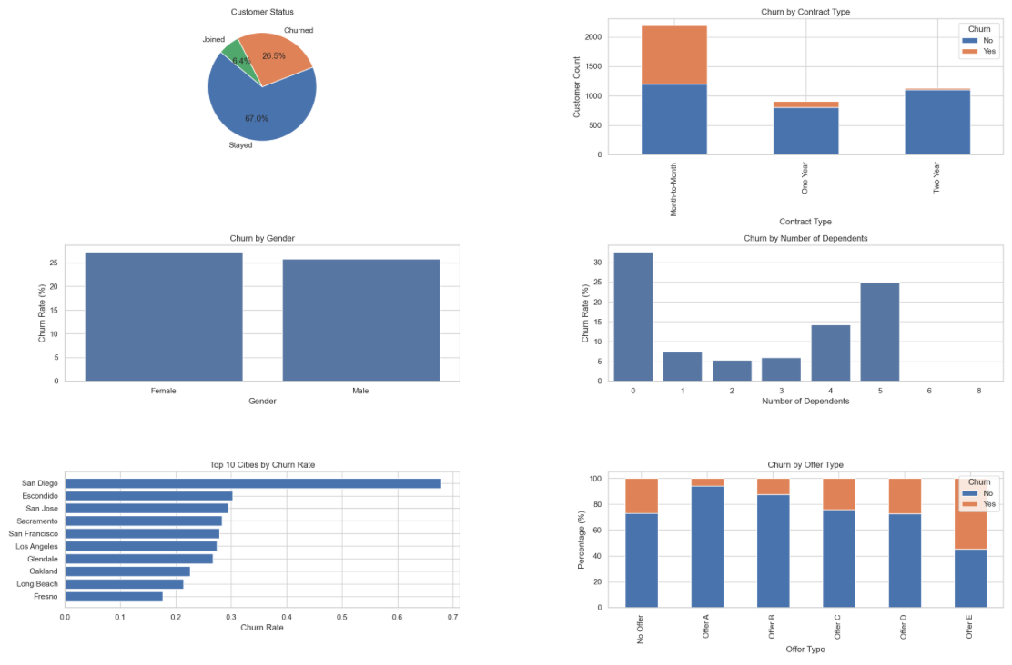
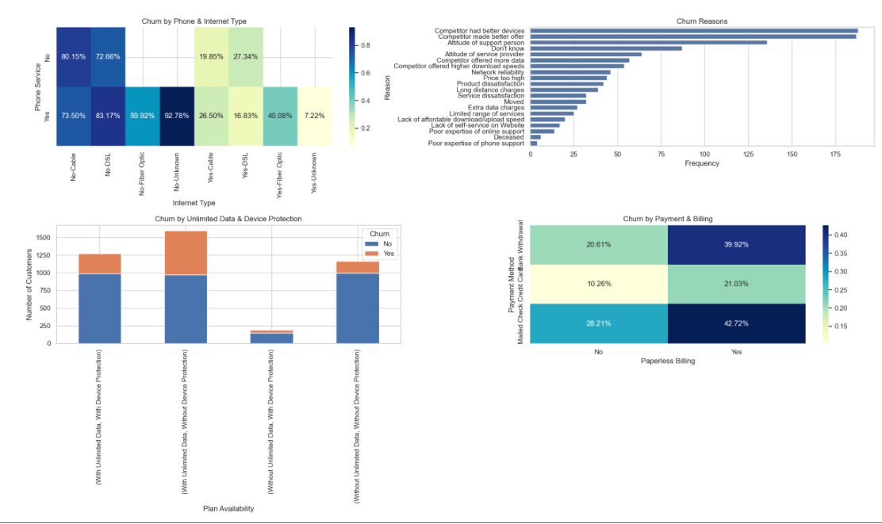

The Telecom Churn Analysis project provides a comprehensive view of customer behavior and churn drivers within the dataset. Through systematic data understanding, cleaning, and analytics computation, key insights were uncovered: high churn among month-to-month contract holders, moderate churn across certain offers, higher churn in specific cities such as San Diego, and notable effects of customer demographics, payment methods, and service plans on retention. Visualizations, including bar charts, pie charts, and heatmaps, helped highlight patterns and high-risk segments effectively. These findings can guide targeted retention strategies, such as improving service quality, optimizing offers, enhancing customer support, and tailoring plans for vulnerable segments, ultimately supporting better customer satisfaction and long-term business stability.

Estimated Working Hours Stage
Data Acquisition 1–2 hours , Data Understanding 2–3 hours , Data Engineering / Cleaning 3–5 hours
Analytics Computation 5–6 hours, Visualization 3–4 hours Reporting & Recommendations 2–3 hours
Total Estimated Hours: ~16–23 hours

